**Question**

The blending problem is considered from an old era when gold coins were used instead of notes for monetary transactions. Robert Baratheon and Ned Stark were two individuals from Southern and northern continents. The winter clothing in that era had a warmth rating of 1 to 10 (1 having the least warmth and 10 having the highest warmth). Winters were very cold in the North compared to the South. Ned Stark wore winter clothing with a warmth rating of at least 9 and Robert Baratheon preferred a winter clothing of warmth rating of at least 5 as winters were pleasant in South. Ned Stark had purchased winter clothing from the Direwolf clothing industry which is situated in the North. There were very few winter clothing manufacturing industries in that old era. One of the major pioneers was the Direwolf clothing industry which mainly focused on manufacturing winter clothing of warmth rating above 8 for the Northerners. However, they had to expand their business by producing winter clothing with lower warmth rating for Southerners because of raven (message or letter) received from Kings Landing (Southern continent). The industry had 100,000 wool yarn of type A with a low warmth rating of 3 and 150,000 wool yarn of type B with a high warmth rating of 10. The profit the industry gained from a winter clothing preferred by Northerners (like Ned Stark) was 100 gold coins (like 100$) and the profit gained by selling a winter clothing preferred by Southerners (like Robert Baratheon) was 150 gold coins (150$). The industry had used a blending method to obtain the best mixture of two types of yarns to produce winter clothes for both Southerners and Northerners.

Objective:

To decide how many yarns of each wool types had to be used to produce two types of winter clothing for Southerners and Northerners.

Discussion:

This problem has two inputs which are the two types of wool yarns 1 and 2 and two outputs of winter clothing one for southerner and one for a northerner. The below diagram illustrates that both input types (the two types of wool yarns 1 and 2) are needed to make both the output types (two outputs of winter clothing one for southerner and one for northerner).

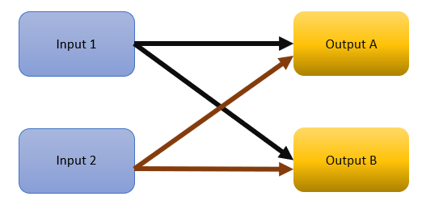

The main thing to consider in this problem is to produce the two outputs with the required warmth ratings. The sum of products of warmth rating and the number of inputs of each type that goes into the considered output type should be greater than the product number of outputs of the considered output type and the corresponding required minimum warmth rating which can be inferred from the image below.

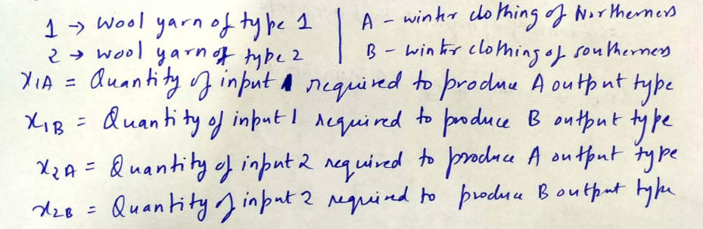

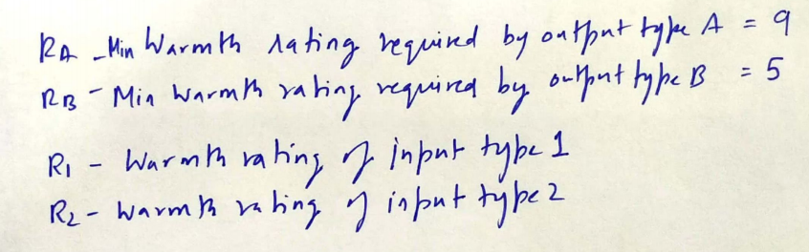

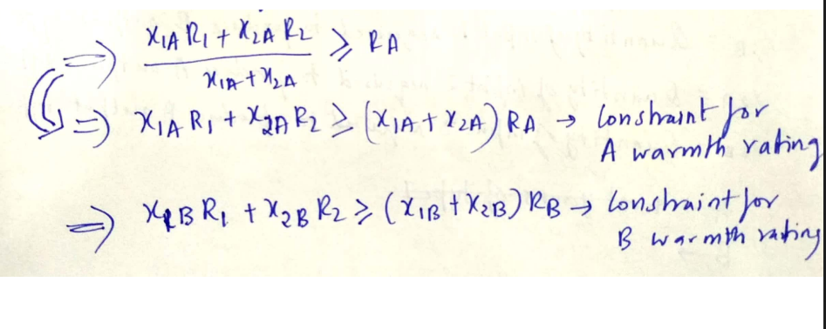

**Mathematical Model**

**Parameters:**

) inputs

**Decision Variables:**

**Objective:**

**Constraints:**